AUGUST
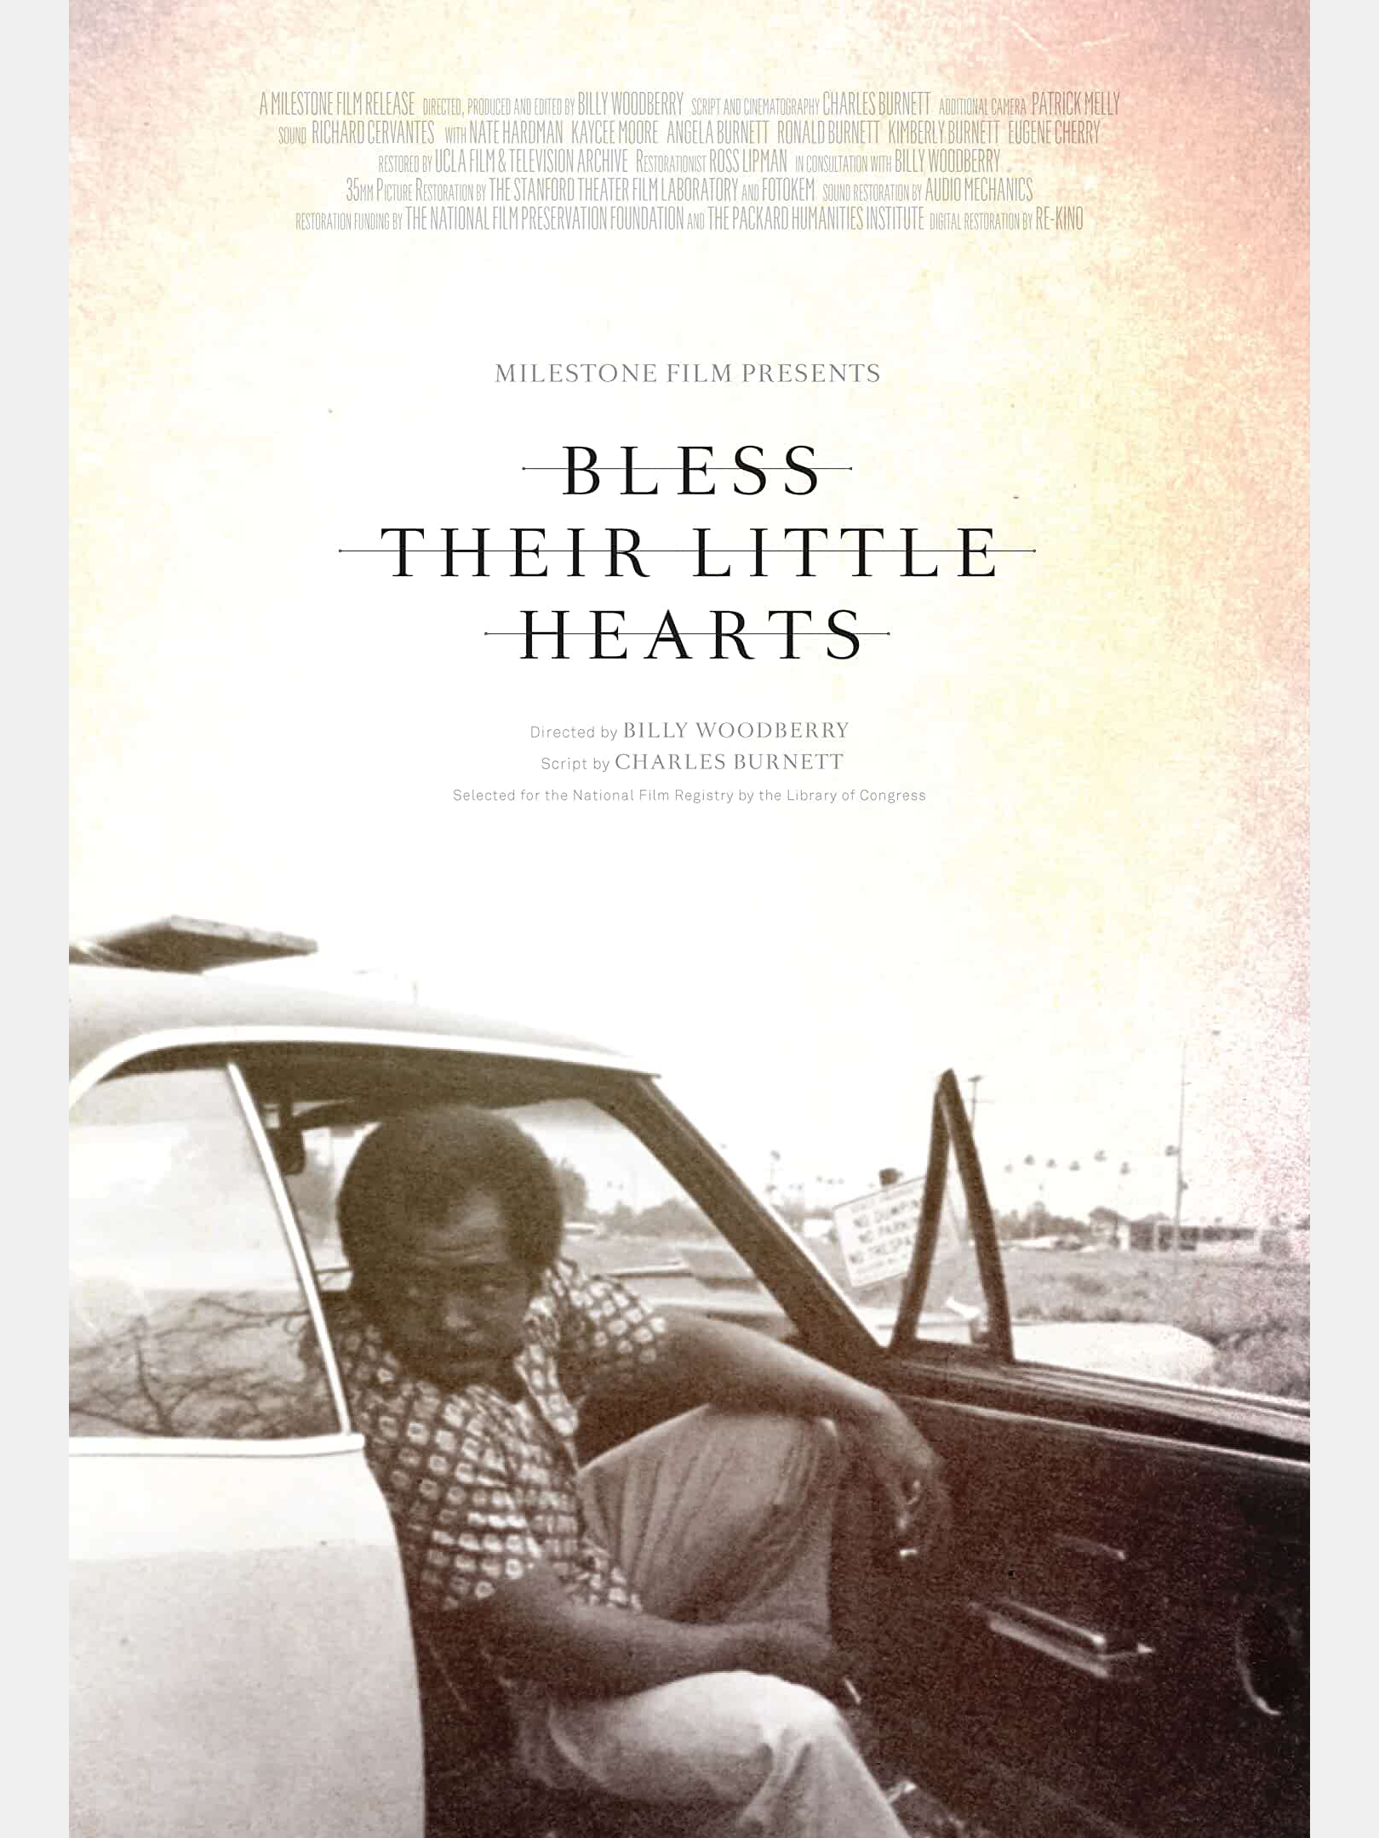

BLESS THEIR LITTLE HEARTS (1983)

Bill Woodberry is an African-American filmmaker. He directs an engaging and unsentimental independent American film about the black experience, a neo-realism one that Hollywood rarely gets right and one mainstream viewers rarely get to see.The romantic drama is set in the mostly black and economically depressed Watts section of Los Angeles. Through focusing on the problems of one black family, we supposedly can observe the everyday lives of those in the community.

SEPTEMBER

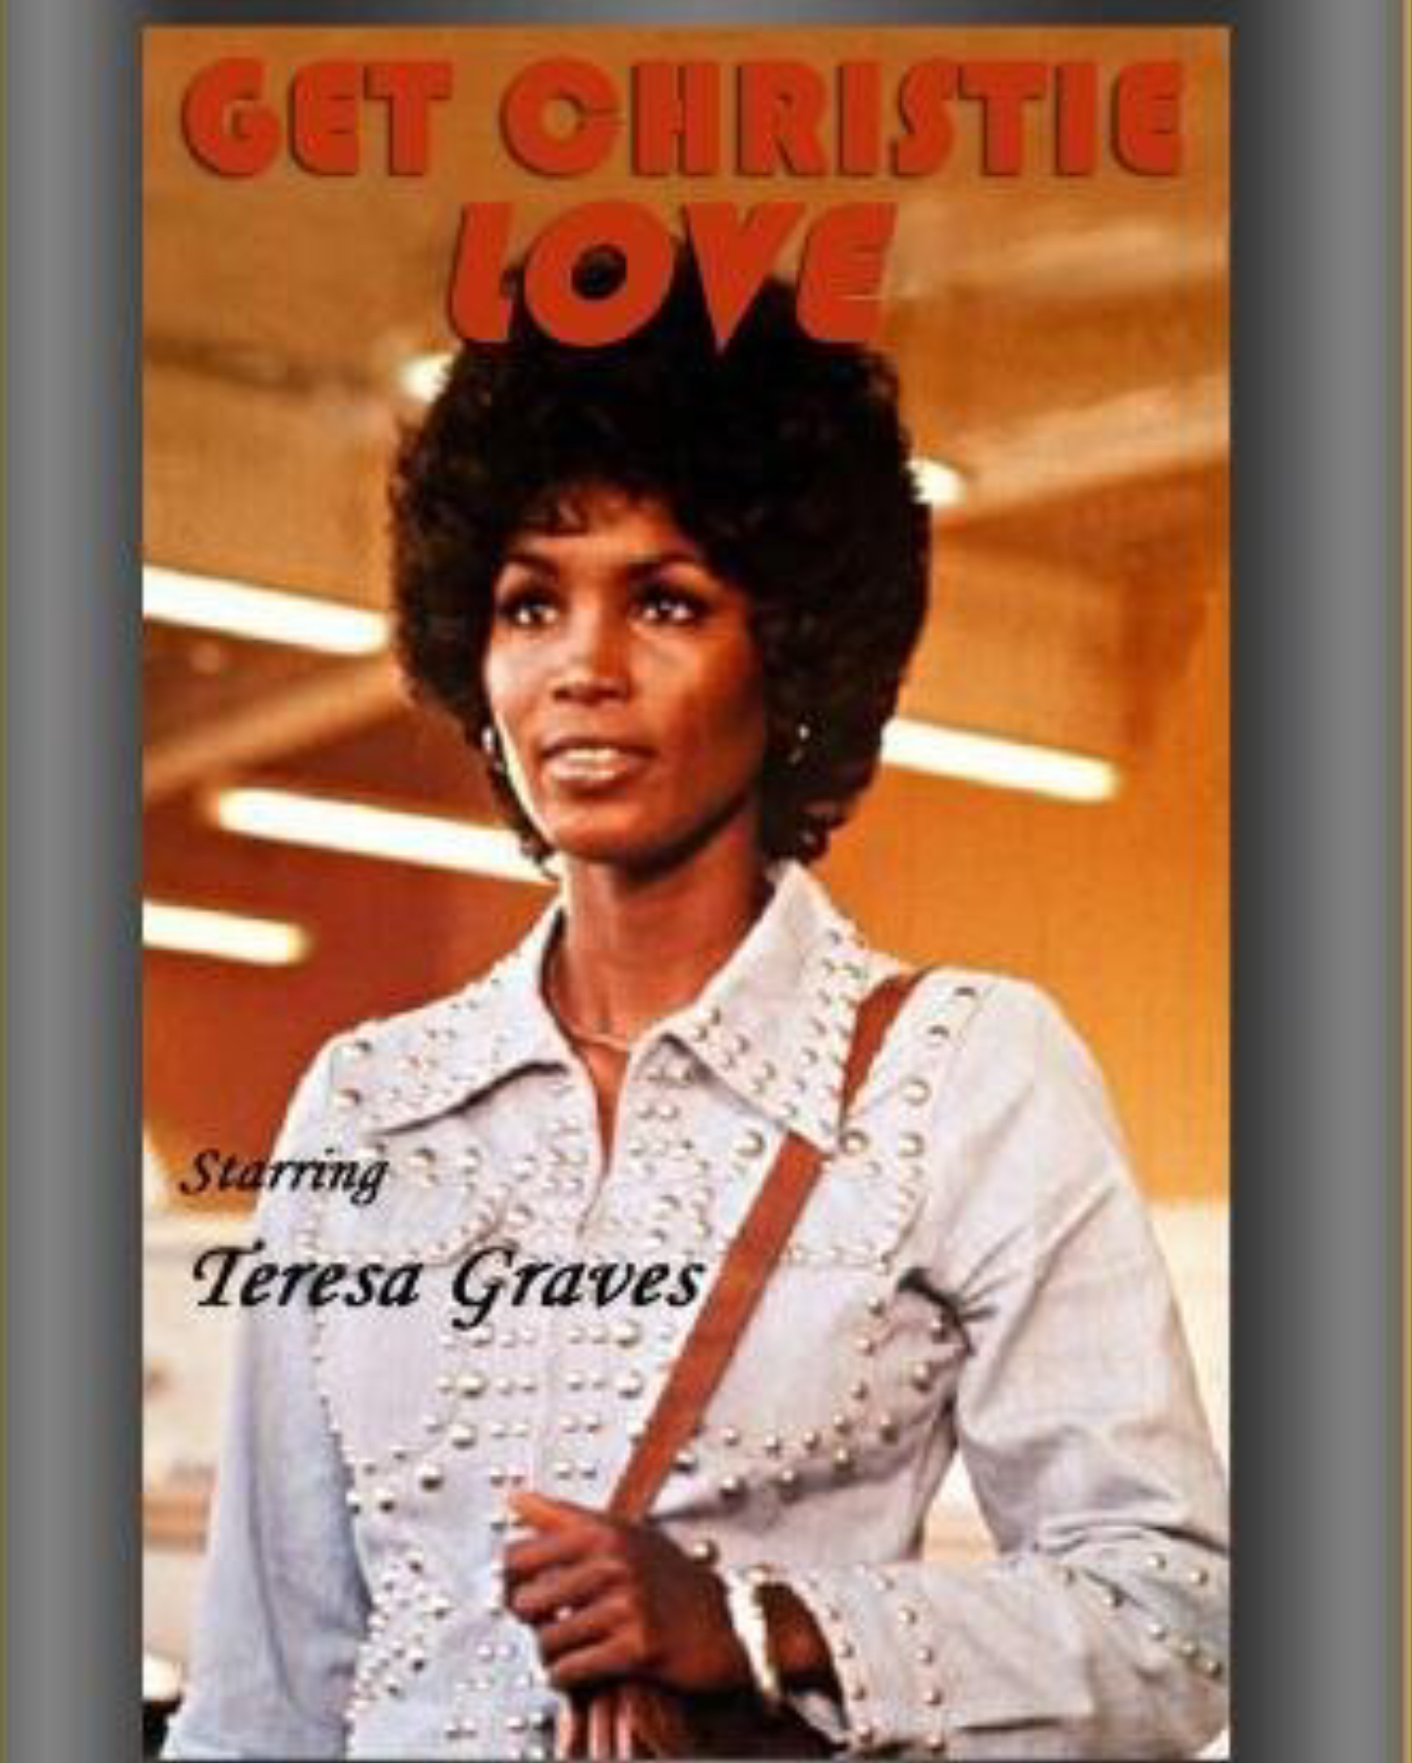

GET CHRISTY LOVE (1974)

We have a Blaxploitation classic from the golden age of this sadly misunderstood genre of kick-ass black women standing up against The Man, man. This is a made-for-television ABC movie, however, so you won't see any of the usual Blaxploitation violence and nudity, which just might have made it more enjoyable to watch. Without the crutches of perky nipples and exploding intestines, the director had to fall back on meaningful dialogue, plot continuity, and character development, all things that, in their complete absence here, end up being the movie's downfall.
Let's meet our heroine Christie Love, played by 26-year old Teresa Graves. Christie is a Homicide Detective in the Los Angeles Police Department (which suggests that she's competent in police procedures, which she isn't) and one hot mamma jamma (supposedly), full of Tyler Perry sass and Aretha Franklin moxie. Befitting her star status, she is always decked out in the latest 1974 fashions, bell-bottom jeans, lots of polyester, platform shoes, rhinestone encrusted denim jackets, and huge hoop earrings.

OCTOBER

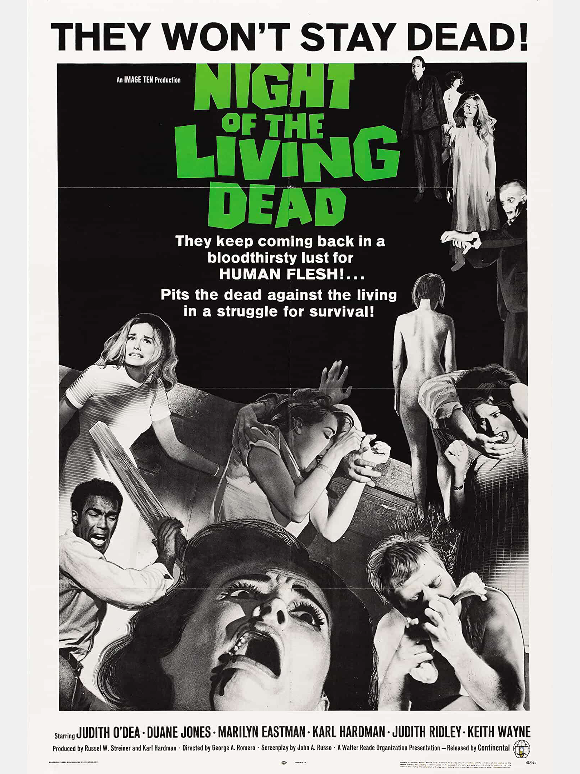

NIGHT OF THE LIVING DEAD (1968)

The movie places seven innocent people trapped in a farmhouse while all around them the undead are gathering, trying to get in and feast on their living flesh. Within the farmhouse there is a main floor and an upper bedroom floor, as well as a cellar. Five people have locked themselves in the cellar thinking that they can lock themselves more securely there. In the main house the smart intelligent Ben takes control of defending the house. Casting African American actor Duane Jones as Ben was a master stroke for filmmaker George Romero, as Jones brings hard tough intelligence to the role. Ben could easily have been portrayed as a gung-ho action hero, instead of the intellectual thinker under fire that Jones brings to the role. Being African American during the racial sensitive era of the 60’s helped define the anger and determination that is needed of the character. It also places a whole new meaning to the movie’s shock ending.

NOVEMBER

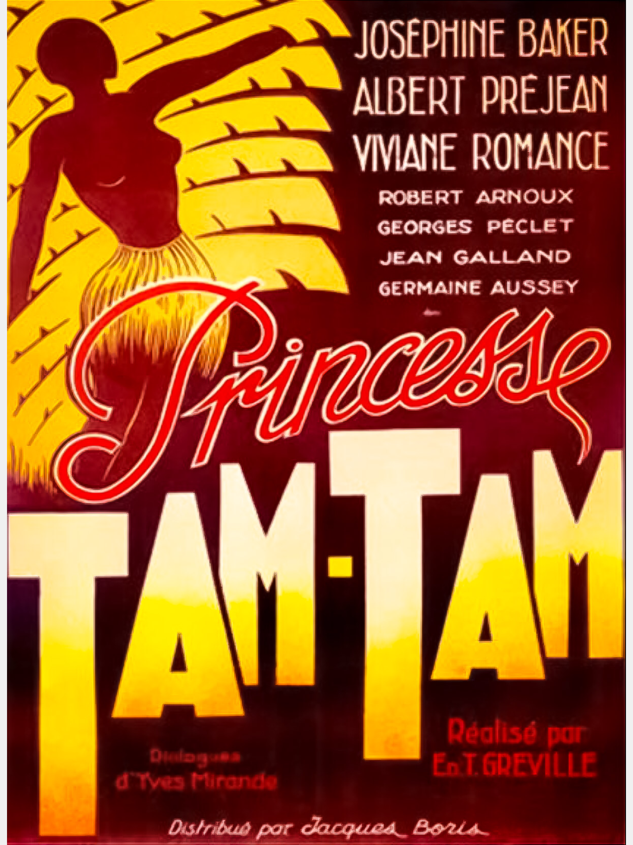

TAM-TAM (1935)

Edmond Greville in this film variation of the Pygmalion theme uses satire to contrast French civilization with a “primitive” African. The film stars the legendary Josephine Baker, who was an exile living in Paris as a famous cabaret entertainer fleeing to escape America’s racism. The film is written by her then real-life husband Pepito Abatino.

DECEMBER

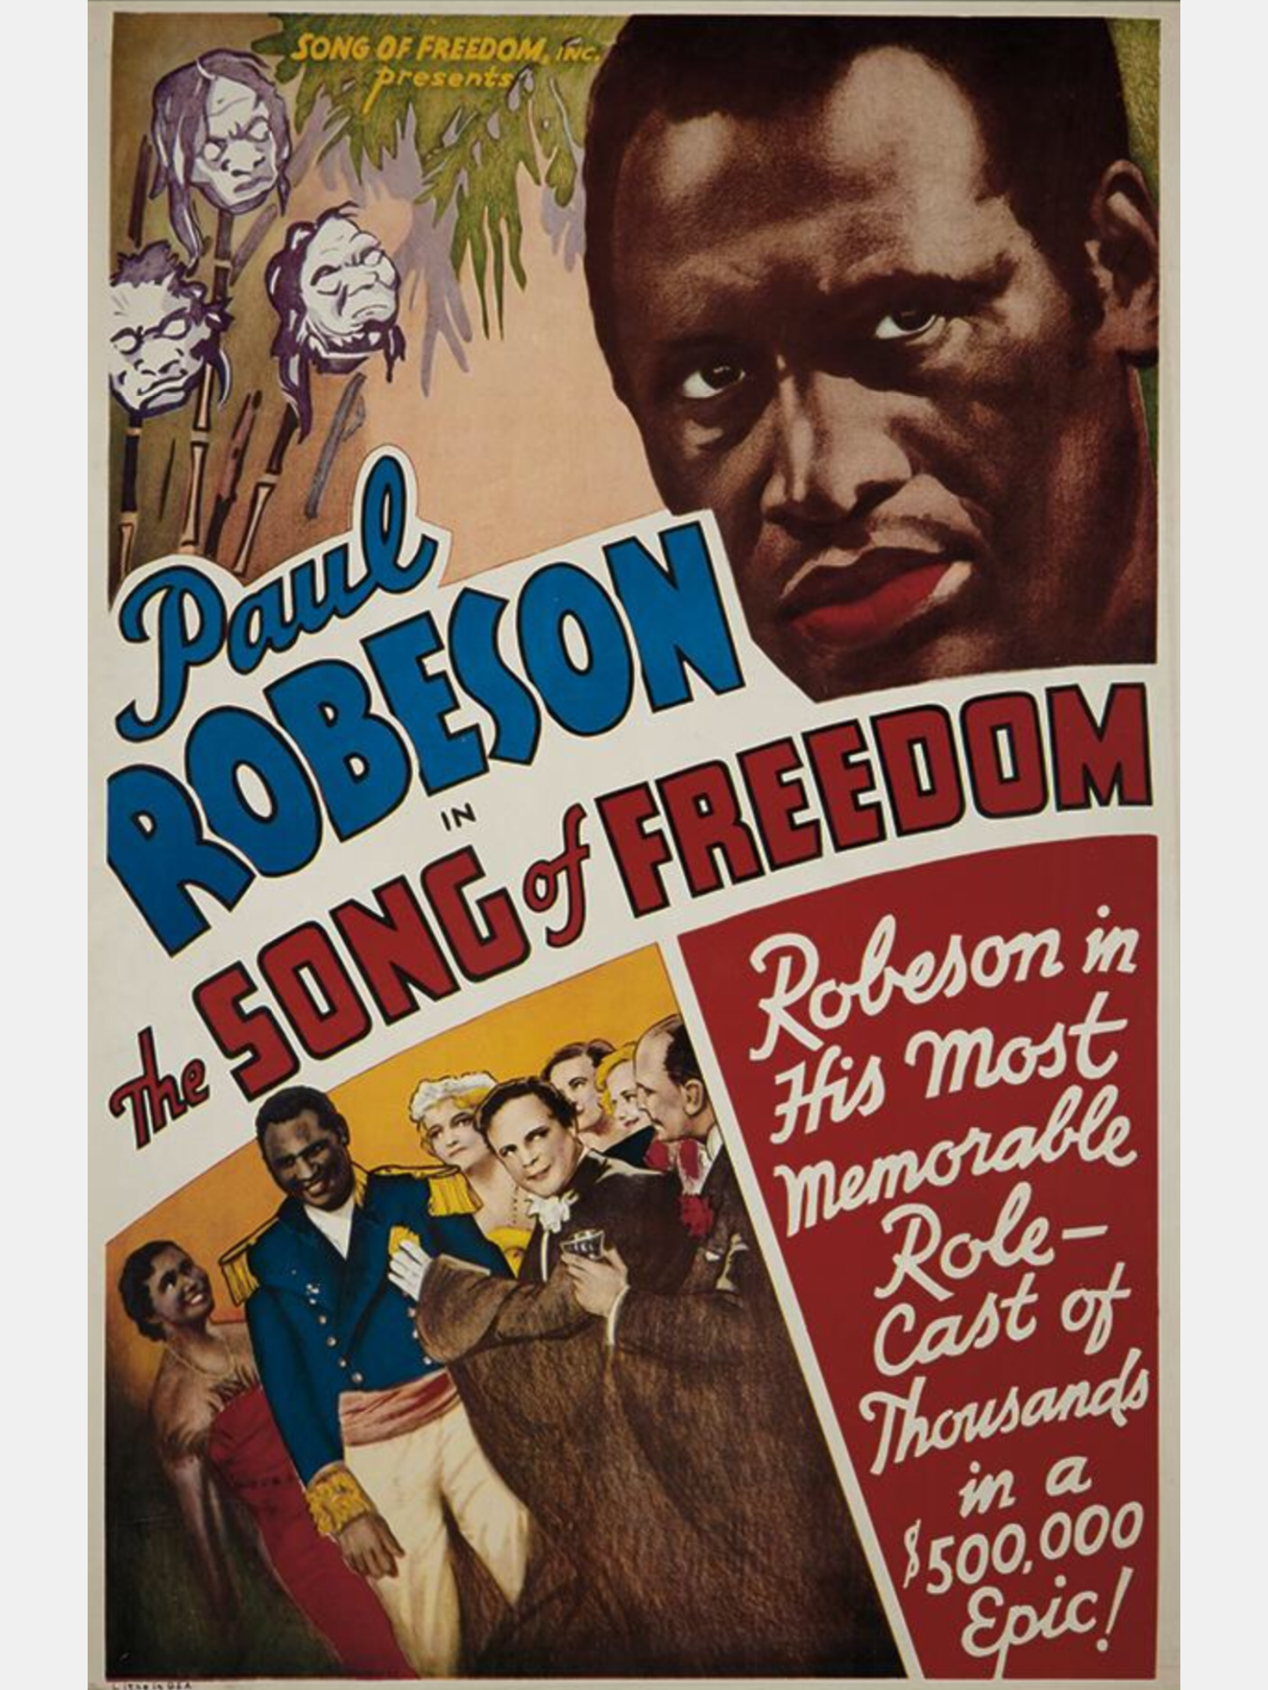

THE SONG OF FREEDOM (1936)

The Song of Freedom stars the celebrated Paul Robeson, an influential African-American figure in history and one of the world’s greatest voices, who is fresh from his success in Sanders of the River. This is the great singers juiciest film role it’s worth seeing just to hear Robeson sing and because of its take on the racial issues of the day.

